Lab 9

Training a Room Explorer using RL

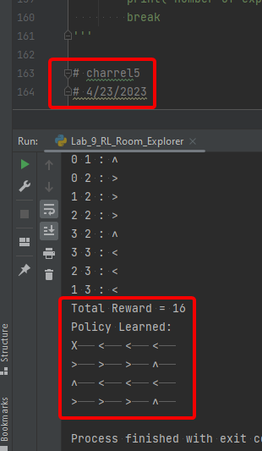

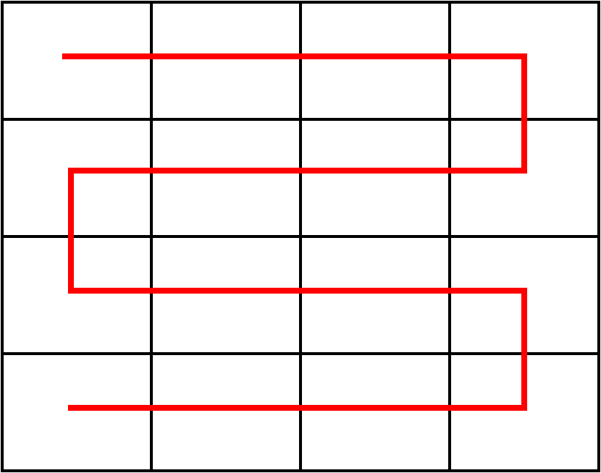

1. How does the optimal policy path look like? Draw the path on a 4 X 4 grid.
   1. 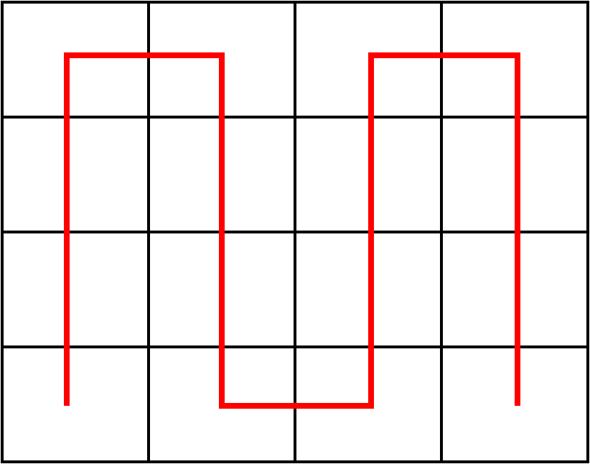
2. Does it contain as much right or left turns as the policies generated by the old reward function?
   1. It contains the same number of turns
3. What is the number of times the exploration task was carried out until the optimal policy was found? (If you are lucky, the code will re run a couple of hundred times. If not, it can keep running for a couple of thousand times before it finds the optimal exploration policy. It should not take more than a couple of minutes maximum.)
   1. 34. See image below

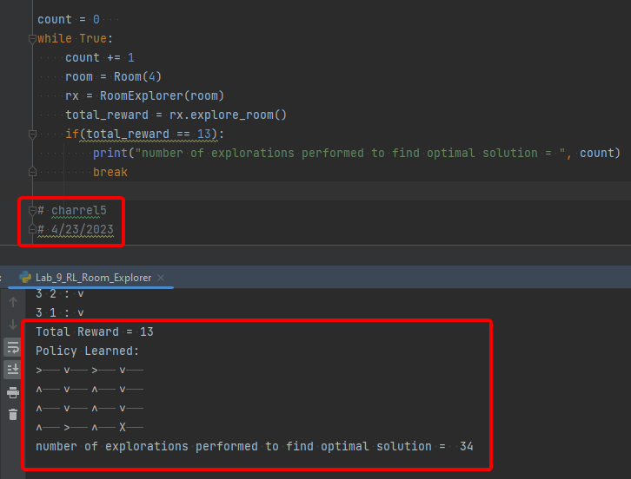

Code and image

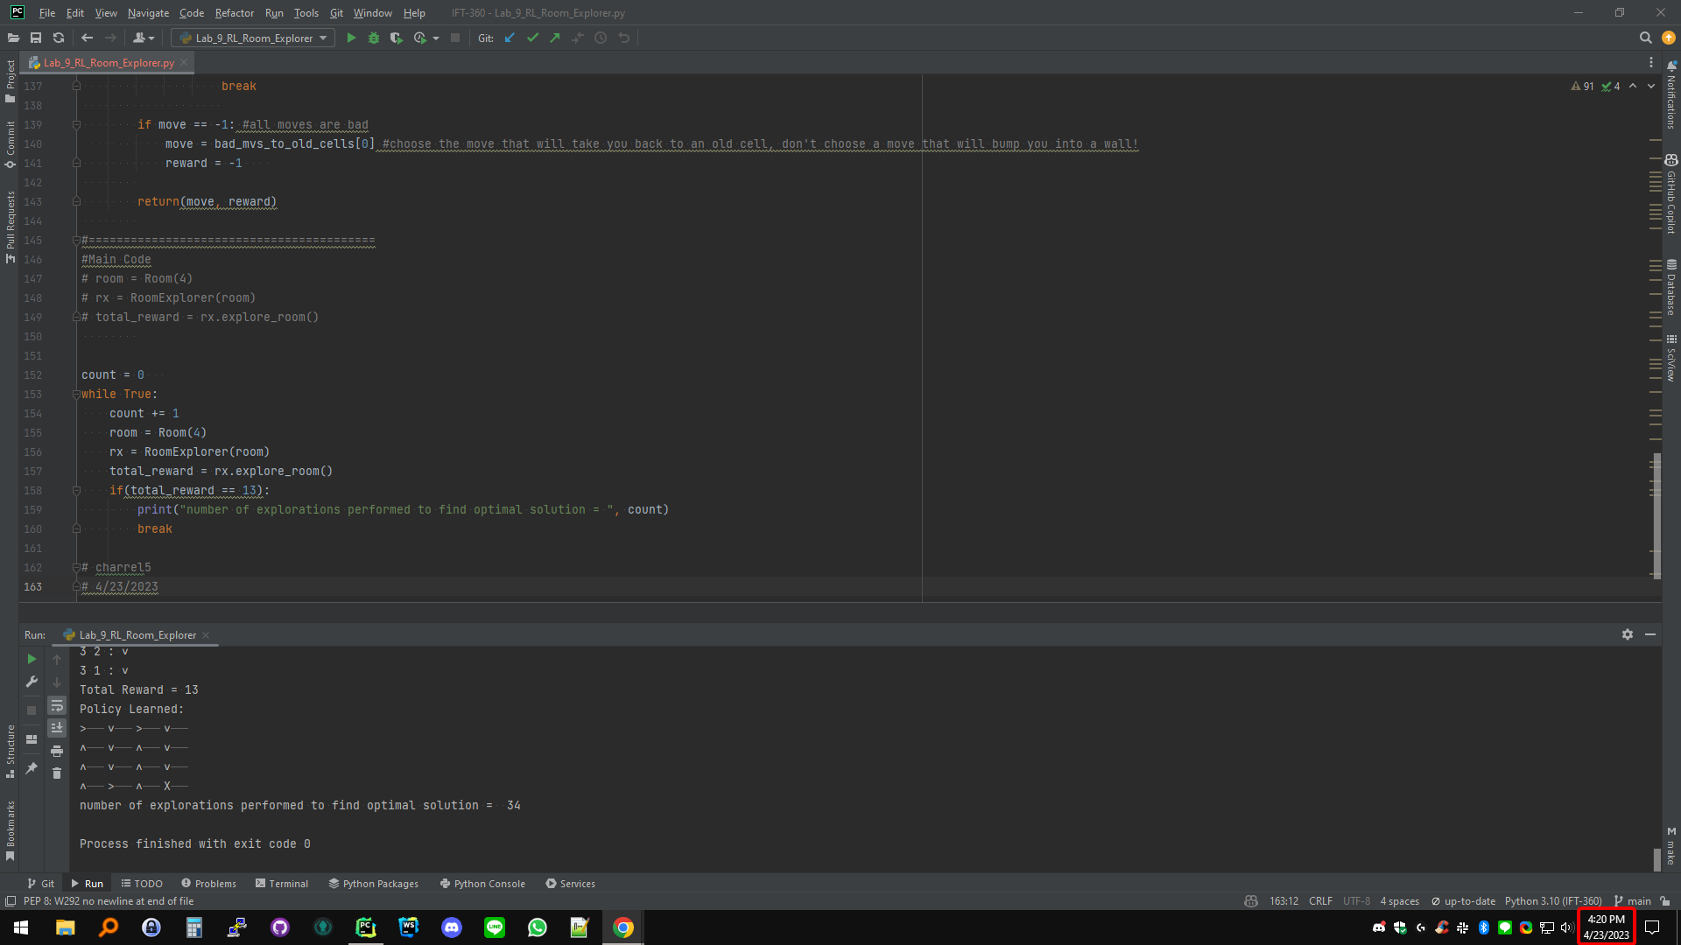

# -*- coding: utf-8 -*-

"""

Created on Wed Sep 21 12:20:43 2022

@author: aelbadra

"""

from random import shuffle

class Room:

def __init__(self, x=5):

self.nrows = x

self.ncols = x

return

class RoomExplorer:

def __init__(self, r):

#initialize the room dimensions

self.room = r

#initialize the total cost

self.cost = 0

#initialize the number of visited cells

self.visited = 0

#initialize the policy

self.policy = []

for i in range(r.nrows):

a=[]

for j in range(r.ncols):

a.append(-1)

self.policy.append(a)

return

#explore a room and build a policy based on returned reward/punishment

#new cell reward = 1

#old cell reward = -1

#bump into wall reward = -1

def explore_room(self):

#intial position = [0,0]

x_p = 0

y_p = 0

total_reward = 1

moves = {0:"∧", 1:"∨", 2:">", 3:"<", -1:"X"}

while True:

#get next move

(move, reward) = self.get_next_move(x_p, y_p)

print(x_p, y_p, ":", moves[move])

#update policy and total reward

self.policy[x_p][y_p] = move

total_reward += reward

#implement the move

if move == 0: # up

y_p += 1

elif move == 1: #down

y_p -= 1

elif move == 2: #right

x_p += 1

elif move == 3: #left

x_p -= 1

#check for termination condition, if true, print policy & return total reward

missing_moves=0

for i in range(self.room.nrows):

for j in range(self.room.ncols):

if self.policy[i][j] == -1:

missing_moves += 1

if missing_moves == 1:

print("Total Reward =", total_reward)

print("Policy Learned:")

for j in range(self.room.ncols-1,-1,-1):

for i in range(self.room.nrows):

print(moves[ self.policy[i][j]], end="\t")

print()

return total_reward

#get the next move to implement based on returned reward/punishment

def get_next_move(self, x_p, y_p):

#generate random move

rand_move = [0,1,2,3]

shuffle(rand_move)

#print("Shuffled moves:", rand_move)

bad_mvs_to_old_cells = []

reward = -1

move = -1

for mv in rand_move:

#calculate reward/punishment based on the reward of the reached cell

if mv == 0: #go up

if y_p + 1 >= self.room.nrows: #if bumping into wall

reward = -1

elif self.policy[x_p][y_p+1] >= 0: #if old cell

reward = -1

bad_mvs_to_old_cells.append(mv)

elif self.policy[x_p][y_p+1] == -1: #if new cell

reward = 1

move = mv

break

elif mv == 1: #go down

if y_p - 1 <0: #if bumping into wall

reward = -1

elif self.policy[x_p][y_p-1] >= 0: #if old cell

reward = -1

bad_mvs_to_old_cells.append(mv)

elif self.policy[x_p][y_p-1] == -1: #if new cell

reward = 1

move = mv

break

#calculate reward/punishment based on the reward of the reached cell

elif mv == 2: #go right

if x_p + 1 >= self.room.ncols: #if bumping into wall

reward = -1

elif self.policy[x_p+1][y_p] >= 0: #if old cell

reward = -1

bad_mvs_to_old_cells.append(mv)

elif self.policy[x_p+1][y_p] == -1: #if new cell

reward = 0

move = mv

break

elif mv == 3: #go left

if x_p - 1 <0: #if bumping into wall

reward = -1

elif self.policy[x_p-1][y_p] >= 0: #if old cell

reward = -1

bad_mvs_to_old_cells.append(mv)

elif self.policy[x_p-1][y_p] == -1: #if new cell

reward = 0

move = mv

break

if move == -1: #all moves are bad

move = bad_mvs_to_old_cells[0] #choose the move that will take you back to an old cell, don't choose a move that will bump you into a wall!

reward = -1

return(move, reward)

#=========================================

#Main Code

# room = Room(4)

# rx = RoomExplorer(room)

# total_reward = rx.explore_room()

count = 0

while True:

count += 1

room = Room(4)

rx = RoomExplorer(room)

total_reward = rx.explore_room()

if(total_reward == 13):

print("number of explorations performed to find optimal solution = ", count)

break

# charrel5

# 4/23/2023

